**https://earth911.com/home-garden/gas-powered-garden/**

**The Gas-Powered Garden: Just Say No**

Gemma Alexander July 17, 2018

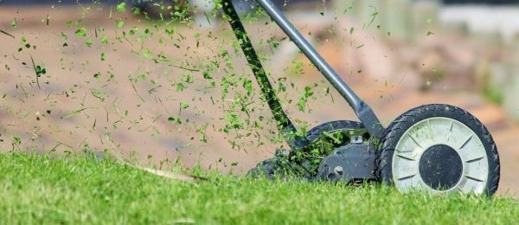

Small, gas-powered engines are about to overtake cars as the worst polluters in California. Operating the best-selling commercial lawn mower for one hour [emits as much smog-forming pollution](https://www.arb.ca.gov/msprog/offroad/sore/sm_en_fs.pdf?_ga=2.94471444.924441919.1530313087-1197644260.1530313087) as driving a Toyota Camry from Los Angeles to Las Vegas.

Not only do gas-powered garden tools contribute to general air pollution, but the gardeners who operate them are exposed to carcinogenic exhaust fumes that raise their risk of [carbon monoxide poisoning](https://www.cdc.gov/niosh/topics/co/) and [respiratory illness](https://www.kqed.org/news/11310630/more-pollution-than-cars-gas-powered-gardening-equipment-poses-the-next-air-quality-threat). In 2020, California will consider new emission standards, but you can just say “No” to gas-powered garden tools now.

**Leaf Blowers**

Most [leaf blowers](https://www.washingtonpost.com/national/health-science/how-bad-for-the-environment-are-gas-powered-leaf-blowers/2013/09/16/8eed7b9a-18bb-11e3-a628-7e6dde8f889d_story.html?noredirect=on&utm_term=.29d8da45930a) utilize a two-stroke engine. Fuel must be mixed with oil in these engines. Only 70 percent of the fuel completely combusts. As a result, two-stroke engines produce nearly 300 times the hydrocarbon emissions of a pickup truck.

Leaf blower haters would argue that the machines are unnecessary in the first place — leaves should be [raked](https://household-tips.thefuntimesguide.com/rake_leaves/) up, not blown around — but if you find them useful, performance [ratings](https://www.consumerreports.org/products/leaf-blower/ratings-overview/) for [electric models](https://amzn.to/2Kt95Bo) are as high as gas.



Performance ratings for electric leaf blowers are as high as gas, without the hydrocarbon emissions. Image source: pixabay.com

**Lawn Mowers**

[Gas mowers](http://www.peoplepoweredmachines.com/faq-environment.htm) are responsible for five percent of U.S. air pollution and each year they result in more spilled fuel than the Exxon Valdez.

[Lawn mowers](https://earth911.com/home/garden/best-lawn-mower/) are not as easy to do without as leaf blowers, but there are plenty of alternatives to gas. You can take the greenest route with a [push mower](https://amzn.to/2INdI3H), but if you must use power, choose [electric](https://amzn.to/2lQn8m8). Both corded and battery models perform as well as a gas lawn mower, with less noise and pollution.

**Hedge Trimmers**

As with all power tools, first consider whether you really need a hedge trimmer. Keeping a hedge from dominating a smaller garden is a high-maintenance proposition no matter what tools you use. If you have enough space, you can plant an [edible hedge](https://earth911.com/home-garden/make-your-urban-yard-the-envy-of-all-creatures-with-these-5-edible-hedges/), which doesn’t require a formal, trimmed shape.

If you already have a formal hedge that’s too big to manage with a manual pair of [shears](https://www.oakhillgardens.com/review/best-hedge-shears), electric is the way to go. Home Depot [reviewed](https://www.homedepot.com/c/buying_guide_hedge_trimmers_HT_BG_OD) power hedge trimmers and found that [electric hedge trimmers](https://amzn.to/2tYZp6z) were not only quieter but also more powerful than gas trimmers.



Could a goat be just the answer to your eco-friendly lawn care dilemma? Image source: pixabay.com

**String Trimmer**

Depending on where you grew up, you call the string trimmer a weed whacker or weed eater. Whatever you call it, the string trimmer is invaluable for overgrown lawns and getting into spaces lawn mowers can’t reach.

The [trade-offs](http://trimmersandedgers.com/gas-trimmers-vs-electric-trimmers/) between gas and electric trimmers are familiar: gas is loud and polluting and causes vibrations that can cause nerve and circulatory damage. However, extension cords may not reach all areas of a very large yard. A cordless electric may not have enough charge to do the whole job at once.

If you are fighting thicker overgrowth, electric trimmers may not have enough power to the get job done. On the other hand, if your brush problem is too big for an [electric trimmer](https://amzn.to/2tNg51T), you might be better off [hiring goats](http://www.goatfinder.com/renting_goats.htm) than using power tools.

*Feature photo by* [*Counselling on Pixabay*](https://pixabay.com/en/lawn-mower-hand-lawn-mower-938555/)