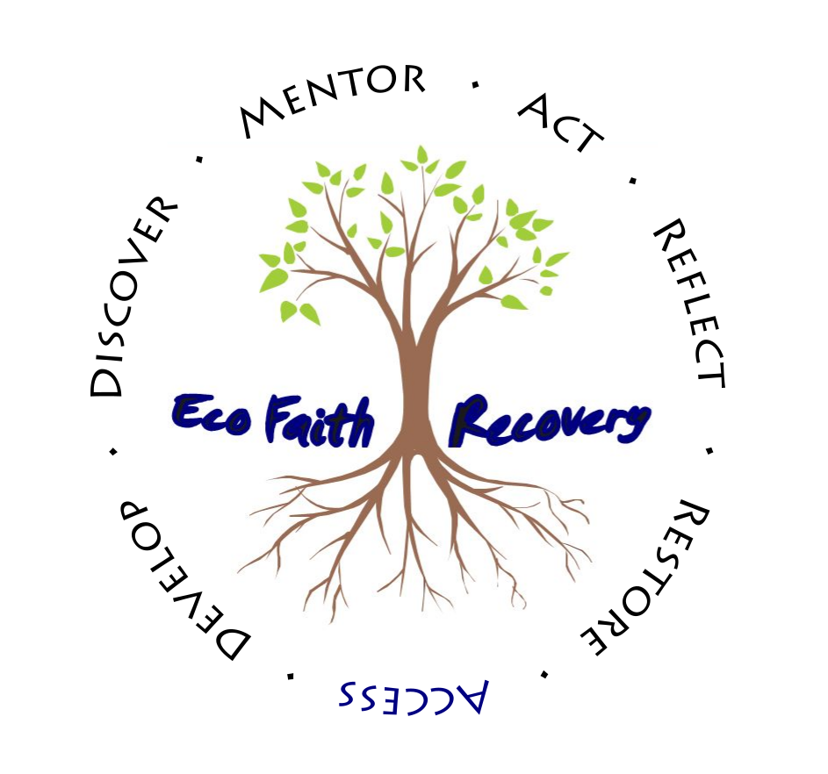
Concerned About Justice for People and the Earth?

A Call to Action: In October 2018, more than 70 leading UN climate scientists declared that we have less than 12 years to dramatically shift towards a renewable energy society to avoid the extreme droughts, floods, heat and poverty that are otherwise virtually inevitable. The need to transition towards just and renewable energy societies has been described as “The Great Work of our Generation.” Now more than ever, we all are called to play our part in the emerging global movement to heal our relationship with the earth, while advancing justice for the disempowered communities harmed the most in a changing climate.

Join EcoFaith Recovery in Taking Action

EcoFaith Recovery is a faith-based grassroots leadership development initiative with a unique role in this emerging global movement. EcoFaith Recovery develops leaders who organize communities to act together for a just world where all have a place at the table, a healthy environment, life-giving work, and a sustainable relationship with creation.
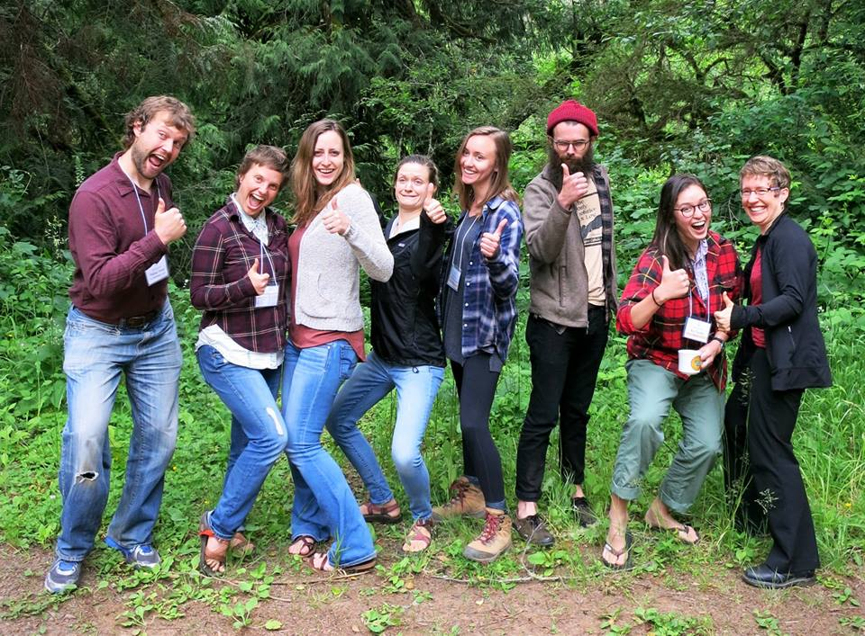
EcoFaith Recovery has cultivated hundreds of leaders through its seven Practices for Awakening Leadership. Since its founding in 2009, EcoFaith has taken strategic and faithful action to inspire emerging leaders through dozens of workshops, organized hundreds of people to participate in public actions, and equipped 30 young adults across the country to engage in leadership projects through year-long mentored, stipended internships.

EcoFaith Recovery leaders have …
- Engaged 30 young adults in internship projects through which they have started a small business to teach gardening to food-insecure people, launched an urban community farm, taught a “Columbia River Watershed Discipleship” course, led a week-long “EcoFaith Youth Camp” inspiring youth to connect faith with creation justice, and more
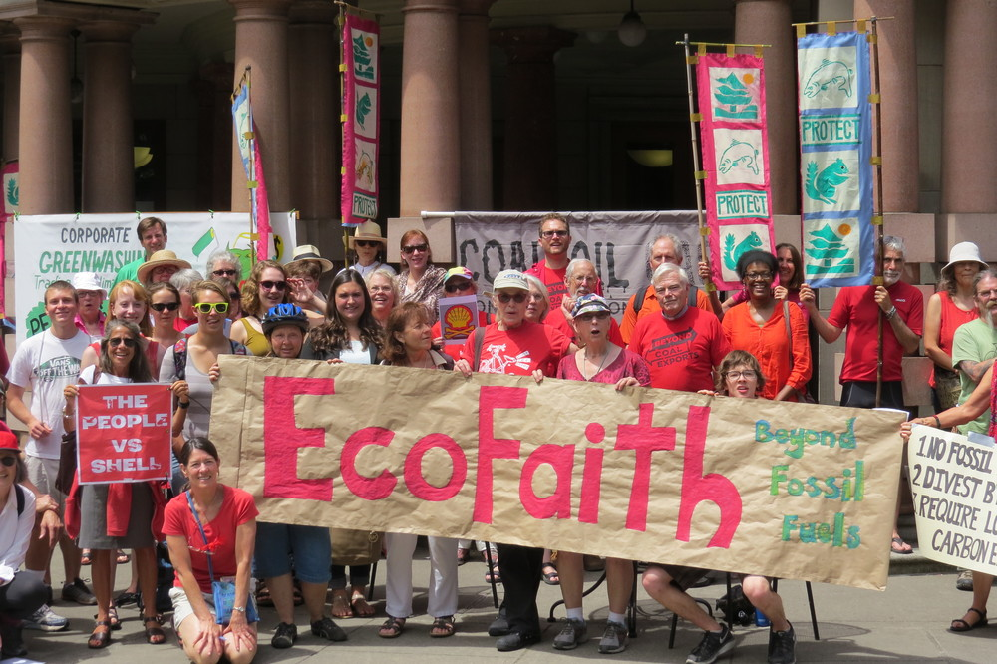
- Organized congregations to collect 2500 signatures to put the “Portland Clean Energy Initiative” on the ballot to create more renewable energy jobs and projects in communities of color and low-income neighborhoods disproportionately harmed by environmental injustice
- Turned out more than 350 people for the People’s Climate March in Portland and another 100 who helped successfully stop fossil fuel expansion in the Northwest
- Mobilized congregations to participate in “Eco-Reformation” Projects, such as a Lenten “Carbon Fast” which reduced emissions by 40,000 pounds and converted a church heating system from oil to biomass.

Now Is The Time
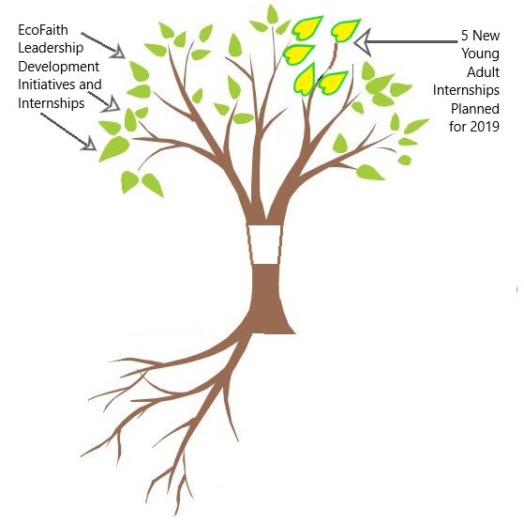
ROOTS = Ongoing Support
$3300 in new recurring
monthly gifts needed

TRUNK = This Year’s Budget

Current automatic monthly gifts range from $5 - $150 per month. Thank you!

EcoFaith Recovery is at a critical juncture as six years of a $25,000 per year start-up grant for our internship program comes to an end.

An increased investment from YOU, especially as a sustaining monthly donor, will enable EcoFaith Recovery to continue its life-changing work and welcome a cohort of five new interns in 2019. Each and every gift will make a significant impact right now, especially while new gifts and the amount of increase from last year’s gifts are being matched.

We are actively pursuing the opportunity to reach a $12,000 Matching Grant by 12/31/18.

How You Can Make a Difference

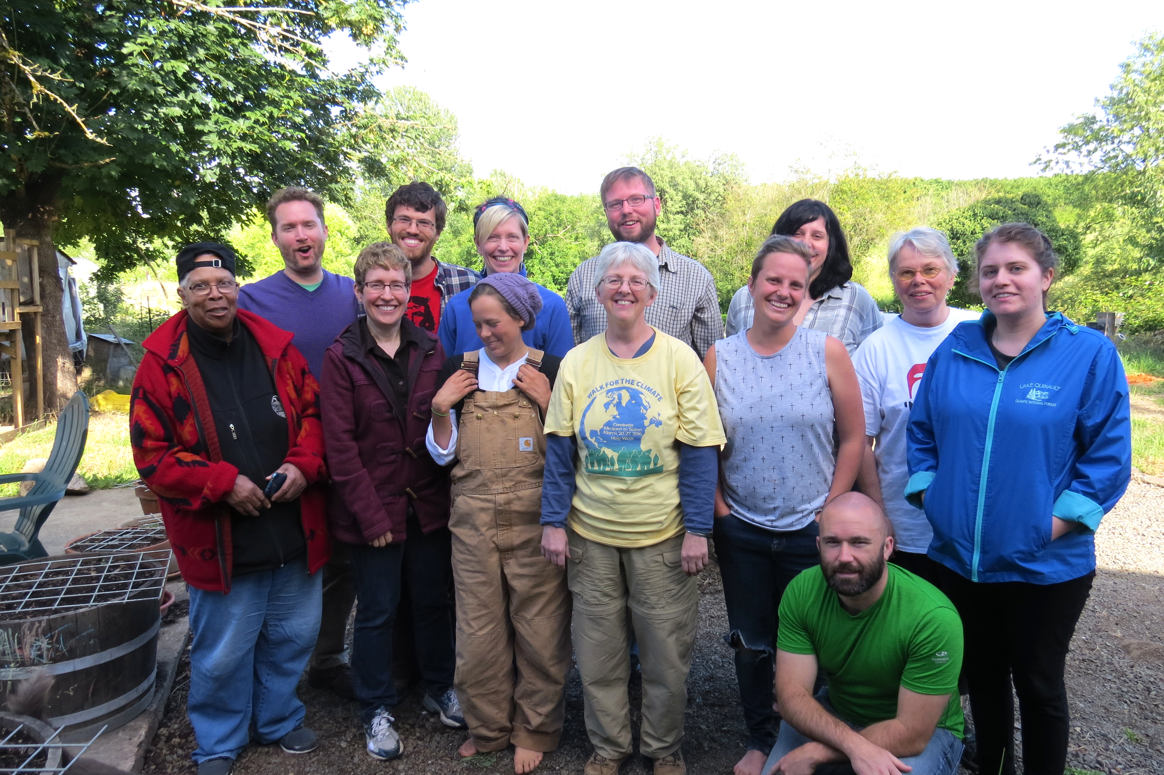
Grow a LEAF! Refer a young adult to EcoFaith Recovery’s annual internship program. Then develop your own leadership capacity by joining new monthly online leadership development gatherings beginning in 2019!

Strengthen the TRUNK! InFaith Community Foundation will MATCH up to $12,000 on any amount above your 2017 gift to EcoFaith Recovery received by 12/31/18.

Become a life-giving ROOT! EcoFaith plans to channel every penny donated and every minute of available time into equipping leaders. Automatic monthly gifts are by far the best way for your gift to offer maximum impact. And, best of all, if you donate now, the 12-month value of your monthly gift will count towards the match! (i.e., a new or increased gift of $50 per month x 12 = $600 annually + $600 matched now = $1,200!)

Questions? Please email Office@ecofaithrecovery.org or PastorRobyn@ecofaithrecovery.org.

Thank you for taking action with EcoFaith Recovery by 12/31/18
to help us “meet our match” and be part of “The Great Work of our Generation.”

