

Organizing in the Biocommons

# *Brought to you by: EcoFaith Recovery, the Wilderness Way Community and Leaven.*

**For clergy and lay leaders of spiritual communities, congregations and networks who are asking…**

**• What** is the nature of the clear, immediate and immense ecological crisis in our region and the biosphere?

**• What** are the impacts of this crisis on our families, congregations and communities?

**• What** are the sources of this crisis?

**• What** are the sources of spiritual wisdom and power we can draw on to creatively and powerfully engage this crisis, and create new possibilities within it?

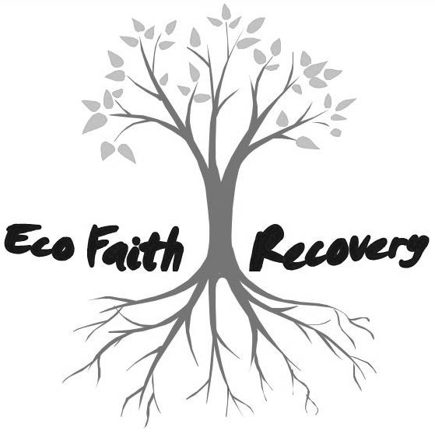

**Why do we do this?**

**Our answer is YES – NO – YES**

**THE FIRST AND GREAT YES** is the power of sacred life manifest in all creation.

**THE NO** is the assault on this sacred life from the concentrated force of oil, natural gas, coal, rail and pipe-line firms, backed by their investors and lenders. **This assault is expressed in three ways:**

**Earth Crisis.** Our climate system is disrupted and the Sixth Great Species Extermination is underway.

**Economic Crisis.** We suffer vast inequalities of wealth, income and power; unemployment, underemployment and mis-employment, all driven by the unsustainable idea of unlimited growth.

**Polis Crisis** (our Democracy). As our classic mediating institutions become irrelevant to public life, we are increasingly ruled by Kleptocracy (corporations control our governments) and Petrocracy (those key corporations in the fossil fuel sector)

**THE SECOND GREAT YES:** This is Our Great Opportunity – Our Great Work – to re-create and co-create a generation of Organized Mediating Communities, which become deeply literate about this YES-NO-YES, in order **to imagine and help create an economy and culture of Creationjustice.** (over)

**Primary Questions Shaping the Content of the Course**

• What are the *systems* of ecology-climate, economy-finance, captive government, and religion-spirituality that underlie the Yes-No-Yes of our current regional/global situation?

• How do our congregations/communities move beyond symptoms and denial, into *root causes and system assumptions* driving our situation?

• How do congregations shift from maintenance-focused, non-mediating institutions to mission-focused, *Organized Mediating Communities*?

• How do we shift, *in our emotions and spirits*, from the current dominant world-view, which is obsolete and destructive, to the emerging world-view, which is life-giving and hope-full?

• How do we *deepen the capacity* of our spiritual communities/networks/congregations so that our people can creatively engage both the Threat and the Great Work of this time and our place?

***Schedule of sessions:***

Track 1

**10 MONDAYS, 6:30pm – 9:00pm**

*Location: Leaven/Salt and Light Lutheran Church, 5431 NE 20th Ave (at Killingsworth)*

**September 15 - November 17**

Track 2

**5 FRIDAYS, 9:00am – 3:30pm**

*Location: September and October: Central Lutheran Church, 1820 NE 21st Ave; November: St. Andrew Lutheran Church, 12405 SW Butner Rd, Beaverton*

**September 19, October 10, October 24, November 7 and November 21**

**For each class:**

• Please **bring** a sack lunch (Friday sessions only)

• **Read** the requiredreadings for each session, which will be posted at [www.ecofaithrecovery.org](http://www.LeavenProject.org)at least two weeks prior to each class.

• **Come ready and open** to develop relationships, share stories, and learn from one another.

***Registration and Fees:***

For planning purposes, PLEASE register by **AUGUST 31, 2014** @ [www.ecofaithrecovery.org](http://www.LeavenProject.org)*.*

**Cost:** $50 for participants who come with a team of 5 or more from their congregation/

community/network. $75 for participants coming as an individual, or in teams of 2 – 4. Please pay for teams by congregation/community/network. *Team members do not all have to participate in the same track.*

**CHILDCARE QUESTIONS:** PastorRobyn@ecofaithrecovery.org (503) 646-0629 x211

**ALL OTHER QUESTIONS:** Dick Harmon ([dickwisingup@hevanet.com](mailto:dickwisingup@hevanet.com); 503-233-0548)

Rev. Solveig Nilsen-Goodin ([solveigng@gmail.com](mailto:solveigng@gmail.com); 503-381-0931)